2014 U3 AOS 2 Outcome 2

Question 3
The production of bioethanol is represented in the flowchart below:
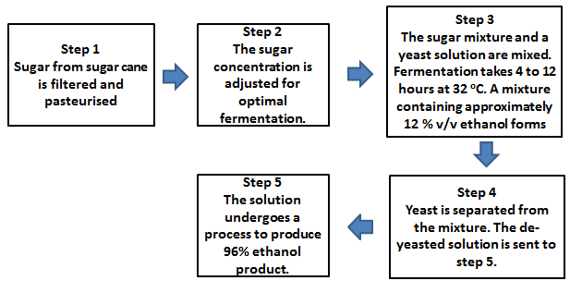

(i) Write a balanced chemical equation for the fermentation process occurring in bioethanol production. Assign states to the reactants and products.

2 marks

(ii) Ethanol is miscible with water whereas octane is not. Use your knowledge of intermolecular bonding to explain why this state is true.

2 marks
(iii) Describe one limitation in the efforts to produce large quantities of bioethanol for use as a fuel

1 mark
b) An alternative method of production of ethanol is shown below.
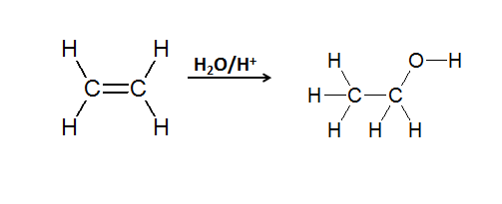
(i) Name the type of reaction shown in the equation.
1 mark

(ii) Would this ethanol be termed bioethanol? Explain your response.

2 marks

Total = 8 marks

